CSA1568-Cloud computing and Big data analytics

Day-1 laboratory

Jashwini A

192124192

1. Create a simple cloud software application and provide it as a service using any Cloud Service Provider to demonstrate Software as a Service (SaaS).

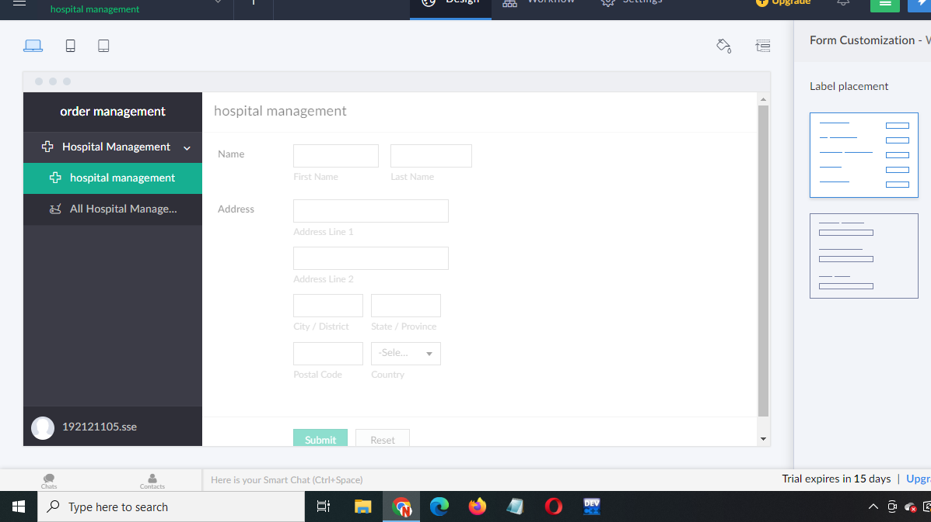

2. Create a simple cloud software application for Flight Reservation System using any Cloud Service Provider to demonstrate SaaS

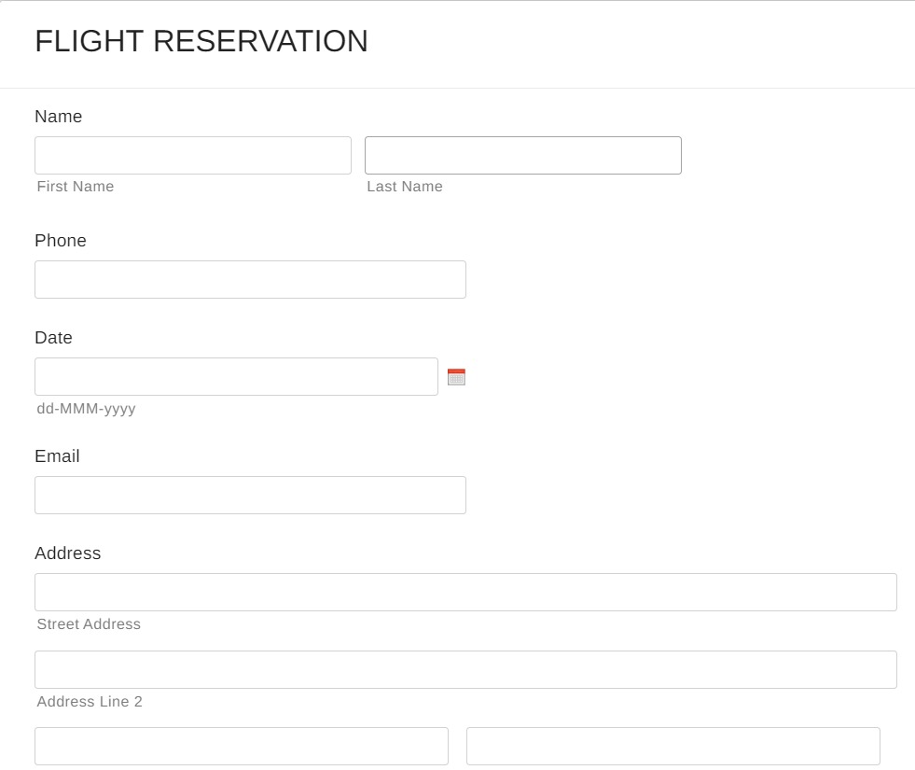

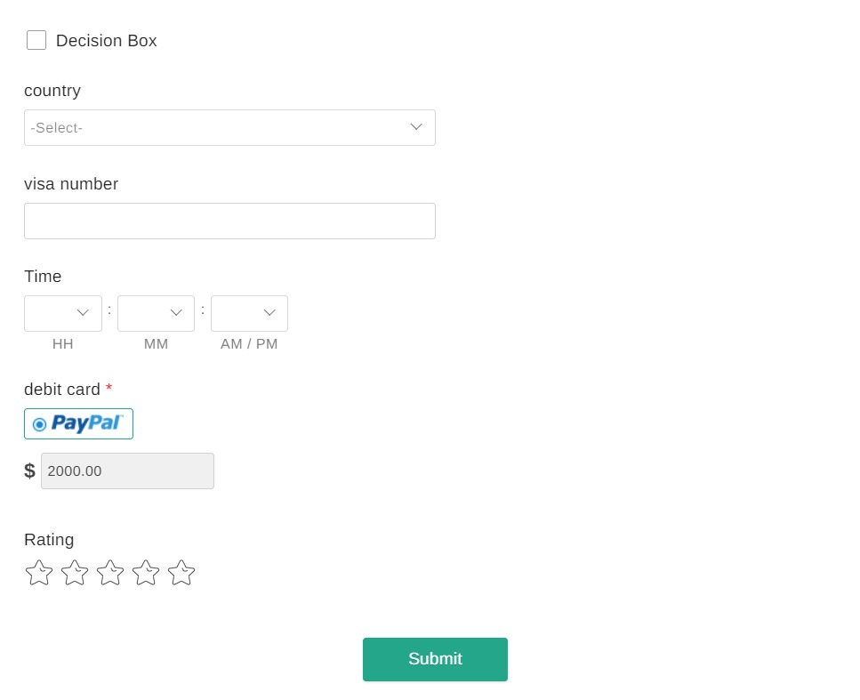

3.Create a simple cloud software application for Property Buying & Rental process (In Chennai city) using any Cloud Service Provider to demonstrate SaaS

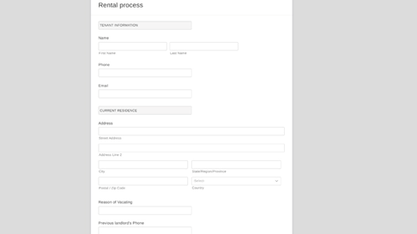

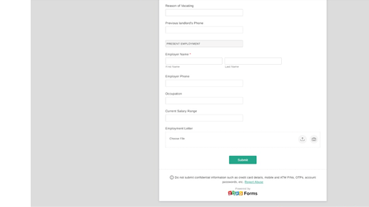

4. Create a simple cloud software application for Car Booking Reservation System using any Cloud Service Provider to demonstrate SaaS.

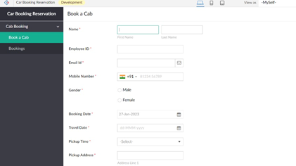

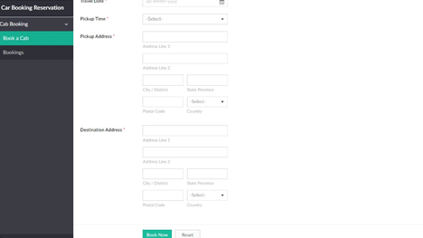

5.Create a simple cloud software application for Library book reservation system for SIMATS library using any Cloud Service Provider to demonstrate SaaS

